|  |
| --- |
| **BMS INSTITUTE OF TECHNOLOGY AND MANAGEMENT**  **Doddaballapura Road, Avalahalli, Yelahanka, Bangalore-560064**  **Affiliated to Visvesvaraya Technological University**    **DEPARTMENT OF MCA**  **2nd SEMESTER MCA**  **COURSE: SOFTWARE ENGINEERING**  **COURSE CODE: 22MCA201**  **LABORATORY RECORD**    **Prepared by: ANIRUDH U PARVATIKAR**  **1BY22MC007**    **ACADEMIC YEAR: 2022-23 (EVEN)** |

|  |  |  |  |  |  |  |
| --- | --- | --- | --- | --- | --- | --- |
| BMS Institute of Technology and Management  (Autonomous Under VTU)  Yelahanka, Bengaluru – 560064.      LABORATORY CERTIFICATE      This is to certify that Mr./Ms _______________________________ has satisfactorily completed the course of experiments in practical __________________________ prescribed by Visveshwaraya Technological University for _____________________ Semester _______________ Course in the  Laboratory of the college in the year 2022 - 2023    **Head of the Department Staff incharge of the batch**  **Date: ______________**     |  |  | | --- | --- | | **Marks** | | | **Maximum** | **Obtained** | |  |  |   **Name of the Candidate: ____________________**  **USN: ________________**            **Signature of the Candidate** |

|  |  |  |
| --- | --- | --- |
| needs  education, state-of-the research and entrepreneurial  **Programme Educational Objectives PEO1:**  **PEO2:**  **PEO3:** Exhibit leadership skills and  **Programme Outcomes (POs)**  **PO1:** Apply knowledge of computing knowledge to provide IT solutions.  **PO2:** Identify, analyse and solve IT sciences.  **PO3:** Design, Develop and evaluate **PO4:** provide valid conclusions.  **PO5:** Select and computing activities.  **PO6:** Understand professional ethics, **PO7:** Involve in life-long learning  **PO8:** Apply and multidisciplinary environments by **PO9:** Comprehend& write effective  **PO10:** Understand and assess the impact of IT solu Issues.  **PO11:** Work collaboratively as a **PO12:** opportunity. | **Department of MCA** | s who            long learning  specialization, mathematics and domain  of mathematics and computing  and environmental concerns. and methods to      professional.      environmental  teams. |
| |  | | --- | | **Department Vision** |   To develop quality professionals in Computer Application can provide sustainable solutions to the societal and industrial   |  | | --- | | **Department Mission** |   Facilitate effective learning environment through quality  -art facilities, and orientation towards skills  **(PEOs)**  Develop innovative IT applications to meet industrial and societal needs Adapt themselves to changing IT requirements through life-  advance in their chosen career  fundamentals, computing    problems using fundamental principles  software solutions to meet societal  Conduct investigations of complex problems using research based knowledge  apply appropriate techniques and modern tools for complex  cyber regulations and responsibilities.  for continual development as an IT  demonstrate computing and management principles to manage projects in involving in different roles reports and make quality presentations. tions on socio-  member or leader in multidisciplinary  Identify potential business opportunities and innovate to create value to the society and seize that |

|  |  |  |  |  |  |  |  |  |  |  |  |  |  |  |  |  |  |  |
| --- | --- | --- | --- | --- | --- | --- | --- | --- | --- | --- | --- | --- | --- | --- | --- | --- | --- | --- |
| **Course Title: Mobile Applications Laboratory**  **Course Code: 22MCA202**  **Course Outcomes (PEOs)**  CO1: Explore the design features of mobile devices.  CO2: Develop applications using views, intents, fragments and graphics.  CO3: Design an application using Internal and external database.  CO4: Design an application using image capturing and location based.  CO5: Develop a mobile application based on societal and environmental issues.  **Laboratory Instructions:**   |  |  | | --- | --- | |  | **Hardware Requirements:** | | Hardware | Above 4GB Ram, Latest Graphic Card, and Android Mobile Phone, Multimedia supported Keyboard and mouse | |  | **Software Requirements:** | | Operating System | Windows (2007 onwards) / Linux OS (Ubuntu / Fedora) | | IDE | Android Studio with Android SDK | | Programming Language/s | JAVA JDK 8 onwards | | Script | JavaScript, PHP, PERL | | Emulator | Built-in with Android Studio or Geny Motion | | Database | Built-in SQLite or Firebase |   **Note:**   1. **Students are required to execute one question from lot of all 9 Questions.** 2. **Change of program is not permitted in the examination.** |

|  |  |  |  |  |  |  |  |  |  |  |  |  |  |  |  |  |  |  |  |  |  |  |  |  |  |  |  |  |  |  |  |  |  |  |  |  |  |  |  |  |
| --- | --- | --- | --- | --- | --- | --- | --- | --- | --- | --- | --- | --- | --- | --- | --- | --- | --- | --- | --- | --- | --- | --- | --- | --- | --- | --- | --- | --- | --- | --- | --- | --- | --- | --- | --- | --- | --- | --- | --- | --- |
| **Particulars of the Experiments to be Performed**  **CONTENTS**   |  |  |  |  | | --- | --- | --- | --- | | **Exp. No.** | **Date** | **Programs** | **Page No.** | | 1 |  | Develop a standard calculator application to perform basic calculations like addition, subtraction, multiplication and division using 2 EditText and 1 TextView for displaying result. | 5 | | 2 |  | Develop a mobile application to register a form in first activity and display the registered information in second activity using intents. | 9 | | 3 |  | Develop a mobile application to list the tourist places of Karnataka using ListView. | 16 | | 4 |  | Devise an application that draws basic graphical primitives (rectangle, circle) on the screen | 19 | | 5 |  | Build a mobile application that create, save, update and delete data in a database. | 21 | | 6 |  | Develop a mobile application that uses GPS location information | 29 | | 7 |  | Create an application that read/writes data to the internal memory of mobile. | 33 | | 8 |  | Build a mobile application to send SMS based on given mobile number with PendingIndents | 37 | | 9 |  | Create simple mobile application using Flutter | 41 | |

**Program-1: Develop a standard calculator application to perform basic calculations like addition, subtraction, multiplication and division** using 2 EditText and 1 TextView for displaying result. (Android

4.0 version used)

**Xml:**

*<?***xml version="1.0" encoding="utf-8"***?>*

<**LinearLayout xmlns:android=**[**"http://schemas.android.com/apk/res/android"**](http://schemas.android.com/apk/res/android) **android:orientation="vertical" android:layout_width="match_parent" android:layout_height="match_parent" android:layout_margin="20dp"**>

<**EditText android:id="@+id/editText1" android:layout_width="match_parent" android:layout_height="wrap_content" android:layout_weight="1" android:inputType="numberDecimal"**

**android:textSize="20sp"** />

<**EditText android:id="@+id/editText2" android:layout_width="match_parent" android:layout_height="wrap_content" android:layout_weight="1" android:inputType="numberDecimal"**

**android:textSize="20sp"** />

<**Button android:id="@+id/Add" android:layout_width="match_parent" android:layout_height="wrap_content" android:layout_weight="1" android:text="+" android:textSize="30sp"**/>

<**Button android:id="@+id/Sub" android:layout_width="match_parent" android:layout_height="wrap_content" android:layout_weight="1" android:text="-" android:textSize="30sp"**/>

<**Button android:id="@+id/Mul" android:layout_width="match_parent" android:layout_height="wrap_content" android:layout_weight="1" android:text="*" android:textSize="30sp"**/>

<**Button android:id="@+id/Div" android:layout_width="match_parent" android:layout_height="wrap_content" android:layout_weight="1" android:text="/" android:textSize="30sp"**/>

<**TextView android:id="@+id/textView" android:layout_width="match_parent" android:layout_height="wrap_content" android:layout_marginTop="50dp" android:text="Answer is" android:textSize="30sp" android:gravity="center"**/> </**LinearLayout**> MainActivity.java

**package** com.example.lab2calculator; **import** android.annotation.SuppressLint; **import** androidx.appcompat.app.AppCompatActivity; **import** android.os.Bundle;

**import**

android.text.TextUtils; **import** android.view.View;

**import** android.view.View.OnClickListener; **import** android.widget.Button;

**import**

android.widget.EditText;

**import**

android.widget.TextView;

**public class** MainActivity **extends** AppCompatActivity **implements** OnClickListener {

EditText **Num1**; EditText **Num2**;

Button **Add**;

Button **Sub**;

Button **Mul**;

Button **Div**;

TextView **Result**;

# @Override

**protected void** onCreate(Bundle savedInstanceState) { **super**.onCreate(savedInstanceState); setContentView(R.layout.***activity_main***);

**Num1** = (EditText) findViewById(R.id.***editText1***);

**Num2** = (EditText) findViewById(R.id.***editText2***);

**Add** = (Button) findViewById(R.id.***Add***);

**Sub** = (Button) findViewById(R.id.***Sub***); **Mul**

= (Button) findViewById(R.id.***Mul***); **Div** = (

Button ) findViewById ( R.id.***Div*** );

**Result** = (TextView) findViewById(R.id.***textView***);

**Add**.setOnClickListener(**this**);

**Sub**.setOnClickListener(**this**);

**Mul**.setOnClickListener(**this**);

**Div**.setOnClickListener(**this**);

}

**public void** onClick (View v)

{ **float** num1 = 0; **float** num2 = 0; **float** result = 0;

String oper = **""**; **if** (TextUtils.*isEmpty*(**Num1**.getText().toString()) || TextUtils.*isEmpty*(**Num2**.getText().toString())) **return**; num1 = Float.*parseFloat*(**Num1**.getText().toString()); num2 = Float.*parseFloat*(**Num2**.getText().toString()); **switch** (v.getId())

{ **case** R.id.***Add***: oper =

**"+"**;

result = num1 + num2; **break**;

**case** R.id.***Sub***: oper =

**"-"**;

result = num1 - num2; **break**;

**case** R.id.***Mul***: oper =

**"*"**;

result = num1 * num2; **break**; **case** R.id.***Div***: oper = **"/"**; result = num1 / num2; **break**;

**default**: **break**;

}

**Result**.setText(num1 + **" "** + oper + **" "** + num2 + **" = "** + result);

}

# @Override

**public void** onPointerCaptureChanged(**boolean** hasCapture) {

}

}

**Output:**

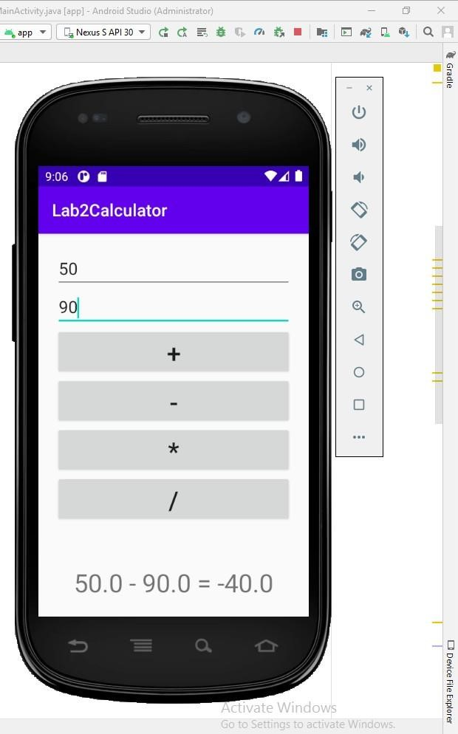

**Program-2:** Develop a mobile application to register a form in first activity and display the registered information in second activity using intents.

**Solution Code:**

**activity_main.xml (First Activity)** <?xml version="1.0" encoding="utf-8"?>

<LinearLayout xmlns:app="http://schemas.android.com/apk/res-auto"

xmlns:tools="http://schemas.android.com/tools" xmlns:android="http://schemas.android.com/apk/res/android" android:layout_width="match_parent" android:layout_height="match_parent" android:orientation="vertical"

tools:context=".MainActivity">

<TextView

android:id="@+id/tv1" android:layout_width="match_parent" android:layout_height="wrap_content" android:layout_marginTop="40dp" android:fontFamily="sans-serif-black" android:gravity="center" android:text="Registration Form" android:textColor="#9C27B0" android:textSize="30dp"

android:textStyle="bold" />

<TextView android:layout_width="match_parent" android:layout_height="wrap_content" android:layout_marginTop="40dp" android:gravity="center" android:text="Enter Full Name" android:textColor="#9C27B0" android:textSize="30sp"

android:textStyle="bold" />

<EditText

android:layout_marginTop="15dp" android:layout_width="match_parent" android:layout_height="wrap_content" android:id="@+id/fullname" android:hint="Full Name"

android:textSize="25dp"/>

<TextView android:layout_width="match_parent" android:layout_height="wrap_content" android:layout_marginTop="25dp" android:gravity="center" android:text="Enter USN" android:textColor="#9C27B0" android:textSize="30sp"

android:textStyle="bold" />

<EditText android:layout_marginTop="20dp" android:layout_width="match_parent" android:layout_height="wrap_content" android:id="@+id/stu_usn" android:hint="USN"

android:textSize="25dp"/>

<TextView android:layout_width="match_parent" android:layout_height="wrap_content" android:layout_marginTop="25dp" android:gravity="center" android:text="Enter Department" android:textColor="#9C27B0" android:textSize="30sp"

android:textStyle="bold" />

<EditText android:layout_marginTop="20dp" android:layout_width="match_parent" android:layout_height="wrap_content" android:id="@+id/clg_Dept" android:hint="Department"

android:textSize="25dp"/>

<Button android:id="@+id/btn" android:layout_width="wrap_content" android:layout_height="wrap_content" android:layout_gravity="center" android:layout_marginTop="20dp" android:background="#1A0467" android:text="SHOW" android:textColor="#FFFFFF"

android:textSize="25dp" />

</LinearLayout>

activity_display.xml (Second Activity)

<?xml version="1.0" encoding="utf-8"?>

<RelativeLayout xmlns:android="http://schemas.android.com/apk/res/android" android:layout_width="match_parent" android:layout_height="match_parent"

android:gravity="top"

android:orientation="vertical">

<TextView android:id="@+id/textView" android:layout_width="match_parent" android:layout_height="wrap_content" android:layout_marginTop="100dp" android:gravity="center" android:text="STUDENT Details" android:textAlignment="center" android:textColor="#C6281C" android:textSize="30sp"

android:textStyle="bold" />

<TextView android:id="@+id/textView1" android:layout_width="match_parent" android:layout_height="wrap_content" android:layout_marginTop="210dp"

android:gravity="center" android:text="NAME" android:textAlignment="center" android:textColor="#C6281C" android:textSize="30sp"

android:textStyle="bold" />

<TextView android:id="@+id/Name" android:layout_width="match_parent" android:layout_height="wrap_content" android:layout_marginTop="260dp"

android:gravity="center" android:text="Empty" android:textAlignment="center" android:textColor="#1682D8" android:textSize="30sp"

android:textStyle="bold" />

<TextView android:id="@+id/textView2" android:layout_width="match_parent" android:layout_height="wrap_content" android:layout_marginTop="340dp" android:gravity="center" android:text="USN" android:textAlignment="center" android:textColor="#C6281C" android:textSize="30sp"

android:textStyle="bold" />

<TextView android:id="@+id/usn2" android:layout_width="match_parent" android:layout_height="wrap_content" android:layout_marginTop="380dp" android:gravity="center" android:text="Empty" android:textAlignment="center" android:textColor="#1375C3" android:textSize="30sp"

android:textStyle="bold" />

<TextView android:id="@+id/textView3" android:layout_width="match_parent" android:layout_height="wrap_content" android:layout_marginTop="460dp" android:gravity="center" android:text="DEPARTMENT" android:textAlignment="center" android:textColor="#C6281C" android:textSize="30sp"

android:textStyle="bold" />

<TextView android:id="@+id/dept2" android:layout_width="match_parent" android:layout_height="wrap_content" android:layout_marginTop="500dp" android:gravity="center" android:text="Empty" android:textAlignment="center" android:textColor="#1A70B5" android:textSize="30sp"

android:textStyle="bold" />

</RelativeLayout>

MainActivity.java

package com.example.myindent;

import androidx.appcompat.app.AppCompatActivity;

import android.content.Intent; import android.os.Bundle; import android.view.View; import android.widget.Button;

import android.widget.EditText;

public class MainActivity extends AppCompatActivity { public static final String Efn = "com.example.MyIndent.Efn"; public static final String Eus = "com.example.MyIndent.Eus"; public static final String Ed = "com.example.MyIndent.Ed";

@Override

protected void onCreate(Bundle savedInstanceState) { super.onCreate(savedInstanceState); setContentView(R.layout.activity_main); Button button = (Button) findViewById(R.id.btn);

button.setOnClickListener(new View.OnClickListener() {

public void onClick(View view)

{

DisActivity();

}

});

}

public void DisActivity() {

EditText et1 = (EditText) findViewById(R.id.fullname);

EditText et2 = (EditText) findViewById(R.id.stu_usn);

EditText et3 = (EditText) findViewById(R.id.clg_Dept);

String fn = et1.getText().toString();

String usn = et2.getText().toString();

String dept = et3.getText().toString();

Intent intent = new Intent(this,DisplayActivity.class); intent.putExtra(Efn,fn); intent.putExtra(Eus,usn); intent.putExtra(Ed,dept); startActivity(intent);

}

}

**DisplayActivity.java**

package com.example.myindent;

import android.content.Intent; import android.os.Bundle;

import android.widget.TextView;

import androidx.appcompat.app.AppCompatActivity;

public class DisplayActivity extends AppCompatActivity {

@Override public void onCreate(Bundle savedInstanceState) { super.onCreate(savedInstanceState); setContentView(R.layout.second_activity);

Intent intent = getIntent();

String s1 = intent.getStringExtra(MainActivity.Efn);

String s2 = intent.getStringExtra(MainActivity.Eus);

String s3 = intent.getStringExtra(MainActivity.Ed);

TextView t1 = (TextView) findViewById(R.id.Name);

TextView t2 = (TextView) findViewById(R.id.usn2);

TextView t3 = (TextView) findViewById(R.id.dept2);

t1.setText(s1); t2.setText(s2); t3.setText(s3);

}

}

AndroidManifest.xml

<?xml version="1.0" encoding="utf-8"?>

<manifest xmlns:android="http://schemas.android.com/apk/res/android" xmlns:tools="http://schemas.android.com/tools">

<application

android:allowBackup="true" android:dataExtractionRules="@xml/data_extraction_rules" android:fullBackupContent="@xml/backup_rules" android:icon="@mipmap/ic_launcher" android:label="@string/app_name" android:roundIcon="@mipmap/ic_launcher_round"

android:supportsRtl="true" android:theme="@style/Theme.MyIndent"

tools:targetApi="31">

<activity

android:name=".MainActivity" android:exported="true">

<intent-filter>

<action android:name="android.intent.action.MAIN" />

<category android:name="android.intent.category.LAUNCHER" />

</intent-filter>

</activity>

<activity android:name=".DisplayActivity" />

</application>

</manifest>

Output:

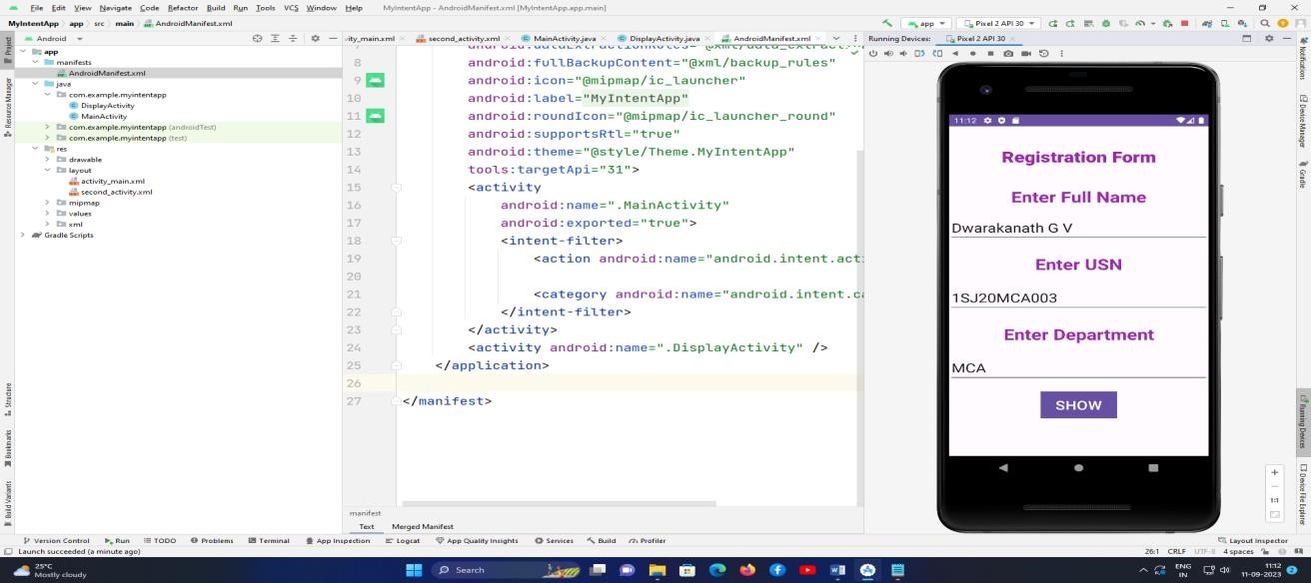

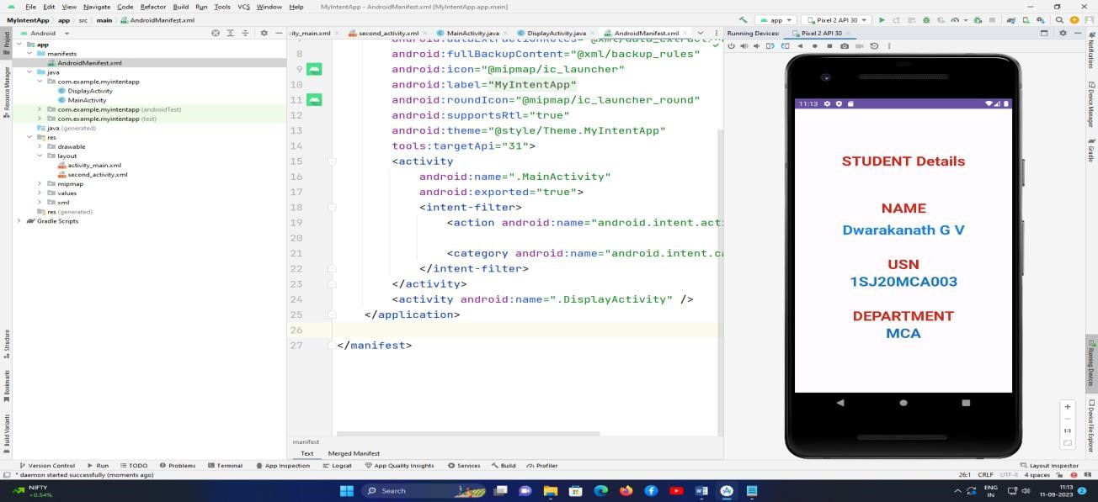

**Program-3:** Develop a mobile application to list the tourist places of Karnataka using ListView.

**Solution Code:**

**Activity_main.xml**

**<?xml version="1.0" encoding="utf-8"?>**

**<LinearLayout xmlns:android="**[**http://schemas.android.com/apk/res/android"**](http://schemas.android.com/apk/res/android) **xmlns:tools="**[**http://schemas.android.com/tools"**](http://schemas.android.com/tools) **android:layout_width="match_parent" android:layout_height="match_parent" android:orientation="vertical"**

**android:scrollbarTrackVertical="@drawable/gandabherunda" android:visibility="visible" tools:context=".MainActivity" tools:visibility="visible">**

**<ImageView android:id="@+id/Kan"**

**android:layout_width="match_parent" android:layout_height="76dp" android:src="@drawable/gandabherunda" android:tooltipText="Emblem of Karnataka State"**

**android:background="#3F51B5"/>**

**<TextView android:id="@+id/tours" android:layout_width="match_parent" android:layout_height="wrap_content" android:background="#090000" android:gravity="center" android:text="Karnataka Tourist Places" android:textColor="#FFFFFF" android:textSize="30dp" android:textStyle="bold"**

**android:fontFamily="sans-serif-medium"/>**

**<LinearLayout android:layout_width="wrap_content" android:layout_height="wrap_content"**

**>**

**<ListView android:id="@+id/places_list" android:layout_width="409dp" android:layout_height="729dp" tools:layout_editor_absoluteX="1dp"**

**tools:layout_editor_absoluteY="1dp" />**

**</LinearLayout>**

**</LinearLayout>**

**Res/layout/Activity_listview.xml**

**<?xml version="1.0" encoding="utf-8"?>**

**<TextView xmlns:android="**[**http://schemas.android.com/apk/res/android"**](http://schemas.android.com/apk/res/android) **android:id="@+id/label" android:layout_width="fill_parent" android:layout_height="fill_parent" android:padding="10dip" android:textSize="25dip" android:textStyle="bold" android:textColor="#690C78"**

**android:background="#00BCD4"**

**android:clickable="true">**

**</TextView>**

**MainActivity.java**

**package com.example.program5touristplaces; import**

**androidx.appcompat.app.AppCompatActivity;**

**import android.os.Bundle; import android.view.View; import android.widget.Adapter; import android.widget.ArrayAdapter; import android.widget.ListAdapter; import android.widget.ListView; import android.widget.TextView; public class MainActivity extends AppCompatActivity {**

**String[] places = {"Bengaluru","Mysore","Nanjanagudu","Jog Falls","Agumbe",**

**"Dharmastala", "Badami","Hampi", "Bagali", "Manasa Sarovara", "Mantralaya", "Chamundi**

**Hills", "Sirsi", "Mahadeswara Hills", "Nandi Hills","Bijapura", "Daroji Karadi Dhama" ,**

**"SiddaroodaMatt", "Horanadu", "Sringeri","Udupi","Madikeri", "Talakadu", "Mekedatu", "Yediyur", "Adichunchanagiri", "Chitradurga","Kottur","Sangama"};**

**@Override protected void onCreate(Bundle savedInstanceState) { super.onCreate(savedInstanceState); setContentView(R.layout.activity_main);**

**ListView listView = (ListView) findViewById(R.id.places_list);**

**Adapter adapter = new ArrayAdapter<String> (this,R.layout.activity_listview, places); listView.setAdapter((ListAdapter) adapter);**

**} }**

**Output:**

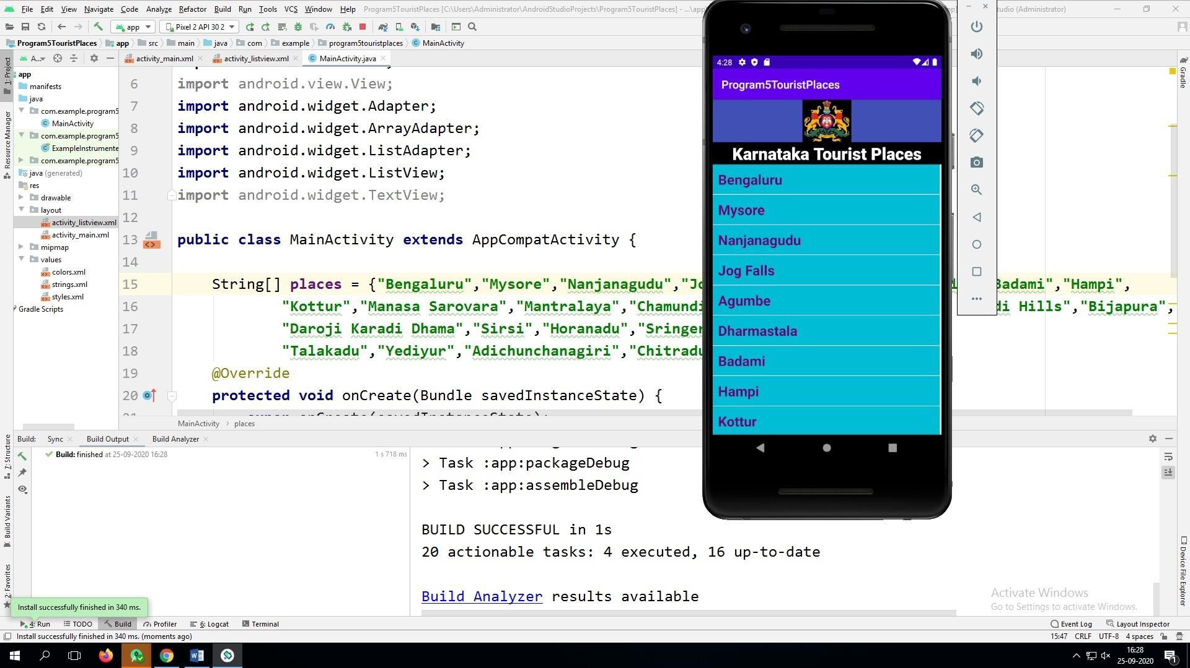

**Program-4: Devise an application that draws basic graphical primitives (rectangle, circle) on the screen Xml:**

*<?***xml version="1.0" encoding="utf-8"***?>*

<**RelativeLayout xmlns:android=**[**"http://schemas.android.com/apk/res/android"**](http://schemas.android.com/apk/res/android) **android:layout_width="match_parent" android:layout_height="match_parent"**>

<**ImageView android:layout_width="match_parent" android:layout_height="match_parent" android:id="@+id/imageView"** />

</**RelativeLayout**>

**Java:**

**package** com.example.prog4;

**import** androidx.appcompat.app.AppCompatActivity; **import** android.os.Bundle;

**import**

android.graphics.Bitmap;

**import** android.graphics.Canvas; **import** android.graphics.Color; **import** android.graphics.Paint;

**import** android.graphics.drawable.BitmapDrawable; **import** android.os.Bundle; **import** android.widget.ImageView;

**public class** MainActivity **extends** AppCompatActivity {

@Override **protected void** onCreate(Bundle savedInstanceState) { **super**.onCreate ( savedInstanceState ); setContentView

( R.layout.***activity_main*** );

Bitmap bg = Bitmap.*createBitmap*(720, 1280, Bitmap.Config.***ARGB_8888***); ImageView i = (ImageView) findViewById(R.id.***imageView***); i.setBackgroundDrawable(**new** BitmapDrawable(bg));

Canvas canvas = **new** Canvas(bg);

Paint paint = **new** Paint();

paint.setColor(Color.***BLUE***);

paint.setTextSize(50);

canvas.drawText(**"Rectangle"**, 420, 150, paint);

canvas.drawRect(400, 200, 650, 700, paint);

canvas.drawText(**"Circle"**, 120, 150, paint);

canvas.drawCircle(200, 350, 150, paint);

canvas.drawText(**"Square"**, 120, 800, paint); canvas.drawRect(50, 850, 350, 1150, paint);

canvas.drawText(**"Line"**, 480, 800, paint); canvas.drawLine(520, 850, 520, 1150, paint);

}

}

**Output:**

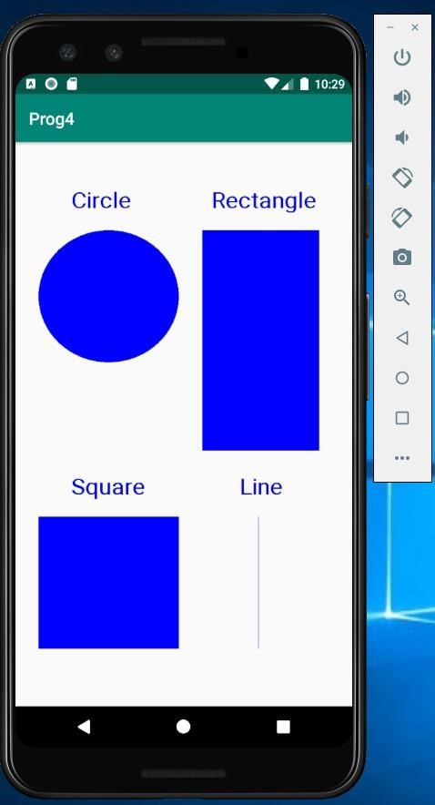

**Program-5: Build a mobile application that create, save, update and delete data in a database. Xml:**

*<?***xml version="1.0" encoding="utf-8"***?>*

<**AbsoluteLayout xmlns:android=**[**"http://schemas.android.com/apk/res/android"**](http://schemas.android.com/apk/res/android) **android:layout_width="match_parent" android:layout_height="match_parent"**>

<**TextView android:layout_width="wrap_content" android:layout_height="wrap_content" android:layout_x="50dp" android:layout_y="20dp" android:text="Student Details" android:textSize="30sp"** />

<**TextView android:layout_width="wrap_content" android:layout_height="wrap_content" android:layout_x="20dp" android:layout_y="110dp" android:text="Enter Rollno:" android:textSize="20sp"** />

<**EditText android:id="@+id/Rollno" android:layout_width="150dp" android:layout_height="wrap_content" android:layout_x="175dp" android:layout_y="100dp" android:inputType="number" android:textSize="20sp"** />

<**TextView android:layout_width="wrap_content" android:layout_height="wrap_content" android:layout_x="20dp" android:layout_y="160dp"**

**android:text="Enter Name:"**

**android:textSize="20sp"** />

<**EditText android:id="@+id/Name" android:layout_width="150dp" android:layout_height="wrap_content" android:layout_x="175dp" android:layout_y="150dp" android:inputType="text" android:textSize="20sp"** />

<**TextView android:layout_width="wrap_content" android:layout_height="wrap_content" android:layout_x="20dp" android:layout_y="210dp" android:text="Enter Marks:" android:textSize="20sp"** />

<**EditText android:id="@+id/Marks" android:layout_width="150dp" android:layout_height="wrap_content" android:layout_x="175dp" android:layout_y="200dp" android:inputType="number" android:textSize="20sp"** />

<**Button**

**android:id="@+id/Insert" android:layout_width="150dp" android:layout_height="wrap_content" android:layout_x="25dp" android:layout_y="300dp" android:text="Insert" android:textSize="30dp"** />

<**Button android:id="@+id/Delete" android:layout_width="150dp" android:layout_height="wrap_content" android:layout_x="200dp" android:layout_y="300dp" android:text="Delete" android:textSize="30dp"** />

<**Button android:id="@+id/Update" android:layout_width="150dp" android:layout_height="wrap_content" android:layout_x="25dp" android:layout_y="400dp" android:text="Update" android:textSize="30dp"** />

<**Button android:id="@+id/View" android:layout_width="150dp"**

**android:layout_height="wrap_content" android:layout_x="200dp" android:layout_y="400dp" android:text="View" android:textSize="30dp"** />

<**Button android:id="@+id/ViewAll" android:layout_width="200dp" android:layout_height="wrap_content" android:layout_x="100dp" android:layout_y="500dp" android:text="View All" android:textSize="30dp"** />

</**AbsoluteLayout**>

**Java:**

**package** com.example.prog5; **import** android.app.Activity; **import** android.app.AlertDialog.Builder; **import** android.content.Context; **import** android.database.Cursor; **import** android.database.sqlite.SQLiteDatabase; **import** android.os.Bundle; **import** android.view.View; **import** android.view.View.OnClickListener; **import** android.widget.Button;

**import** android.widget.EditText;

**public class** MainActivity **extends** Activity **implements** OnClickListener {

EditText **Rollno**,**Name**,**Marks**;

Button **Insert**,**Delete**,**Update**,**View**,**ViewAll**;

SQLiteDatabase **db**;

@Override **public void** onCreate(Bundle savedInstanceState)

{

**super**.onCreate(savedInstanceState);

setContentView(R.layout.***activity_main***);

**Rollno**=(EditText)findViewById(R.id.***Rollno***);

**Name**=(EditText)findViewById(R.id.***Name***); **Marks**=(EditText)findViewById(R.id.***Marks***);

**Insert**=(Button)findViewById(R.id.***Insert***);

**Delete**=(Button)findViewById(R.id.***Delete***);

**Update**=(Button)findViewById(R.id.***Update***);

**View**=(Button)findViewById(R.id.***View***);

**ViewAll**=(Button)findViewById(R.id.***ViewAll***);

**Insert**.setOnClickListener(**this**);

**Delete**.setOnClickListener(**this**);

**Update**.setOnClickListener(**this**);

**View**.setOnClickListener(**this**);

**ViewAll**.setOnClickListener(**this**);

**db**=openOrCreateDatabase(**"StudentDB"**, Context.***MODE_PRIVATE***, **null**); **db**.execSQL(**"CREATE TABLE IF NOT EXISTS student(rollno VARCHAR,name VARCHAR,marks VARCHAR);"**);

}

**public void** onClick(View view)

{

**if**(view==**Insert**)

{ **if**(**Rollno**.getText().toString().trim().length()==0||

**Name**.getText().toString().trim().length()==0||

**Marks**.getText().toString().trim().length()==0)

{

showMessage(**"Error"**, **"Please enter all values"**); **return**;

}

**db**.execSQL(**"INSERT INTO student VALUES('"**+**Rollno**.getText()+**"','"**+**Name**.getText()+

**"','"**+**Marks**.getText()+**"');"**);

showMessage(**"Success"**, **"Record added"**); clearText(); }

**if**(view==**Delete**)

{

**if**(**Rollno**.getText().toString().trim().length()==0)

{

showMessage(**"Error"**, **"Please enter Rollno"**); **return**;

}

Cursor c=**db**.rawQuery(**"SELECT * FROM student WHERE rollno='"**+**Rollno**.getText()+**"'"**, **nul**

**l**);

**if**(c.moveToFirst())

{

**db**.execSQL(**"DELETE FROM student WHERE rollno='"**+**Rollno**.getText()+**"'"**); showMessage(**"Success"**, **"Record Deleted"**);

} **else**

{

showMessage(**"Error"**, **"Invalid Rollno"**);

}

clearText(); }

**if**(view==**Update**)

{

**if**(**Rollno**.getText().toString().trim().length()==0)

{

showMessage(**"Error"**, **"Please enter Rollno"**); **return**; }

Cursor c=**db**.rawQuery(**"SELECT * FROM student WHERE rollno='"**+**Rollno**.getText()+**"'"**, **nul**

**l**); **if**(c.moveToFirst()) { **db**.execSQL(**"UPDATE student SET name='"** + **Name**.getText() + **"',marks='"** +

**Marks**.getText() +

**"' WHERE rollno='"**+**Rollno**.getText()+**"'"**); showMessage(**"Success"**, **"Record Modified"**);

} **else** {

showMessage(**"Error"**, **"Invalid Rollno"**);

}

clearText(); }

**if**(view==**View**)

{

**if**(**Rollno**.getText().toString().trim().length()==0)

{

showMessage(**"Error"**, **"Please enter Rollno"**); **return**; }

**null**);

c=**db**.rawQuery(**"SELECT * FROM student WHERE rollno='"**+**Rollno**.getText()+**"'"**,

**if**(c.moveToFirst())

{

**Name**.setText(c.getString(1));

**Marks**.setText(c.getString(2));

} **else**

{

showMessage(**"Error"**, **"Invalid Rollno"**);

clearText();

}

}

**if**(view==**ViewAll**)

{

Cursor c=**db**.rawQuery(**"SELECT * FROM student"**, **null**); **if**(c.getCount()==0)

{

showMessage(**"Error"**, **"No records found"**); **return**;

}

StringBuffer buffer=**new** StringBuffer();

**while**(c.moveToNext())

{

buffer.append(**"Rollno: "**+c.getString(0)+**"\n"**); buffer.append(**"Name: "**+c.getString(1)+**"\n"**); buffer.append(**"Marks: "**+c.getString(2)+**"\n\n"**);

} showMessage(**"Student Details"**, buffer.toString());

} }

**public void** showMessage(String title,String message) {

Builder builder=**new** Builder(**this**); builder.setCancelable(**true**); builder.setTitle(title); builder.setMessage(message); builder.show();

}

**public void** clearText()

{

**Rollno**.setText(**""**);

**Name**.setText(**""**);

**Marks**.setText(**""**);

**Rollno**.requestFocus();

}

}

**Output:**

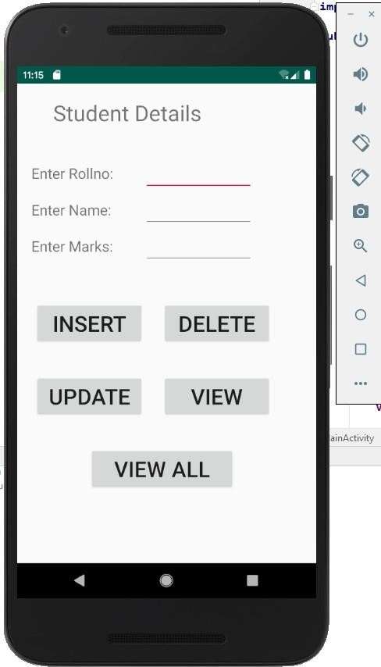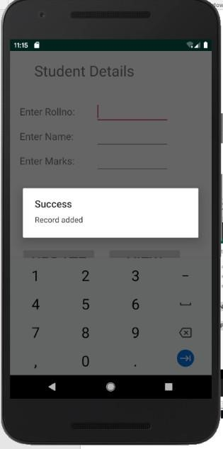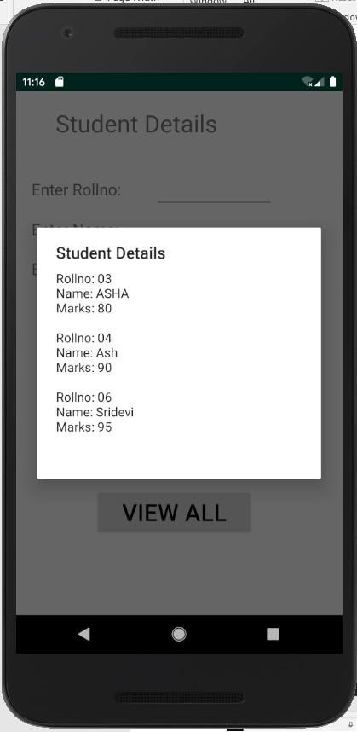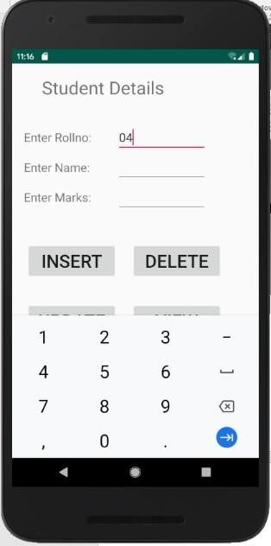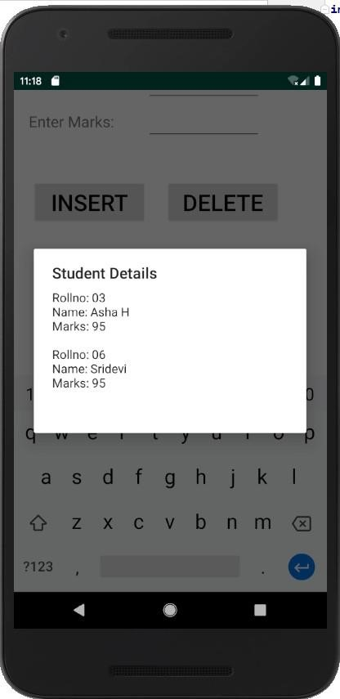

**Program-6: Develop a mobile application that uses GPS location information Xml:**

*<?***xml version="1.0" encoding="utf-8"***?>*

<**androidx.constraintlayout.widget.ConstraintLayout xmlns:android="**[**http://schemas.android.com/apk/res/android"**](http://schemas.android.com/apk/res/android) **xmlns:app="**[**http://schemas.android.com/apk/res-auto"**](http://schemas.android.com/apk/res-auto) **xmlns:tools="**[**http://schemas.android.com/tools"**](http://schemas.android.com/tools) **android:layout_width="match_parent" android:layout_height="match_parent" tools:context=".MainActivity"**>

<**LinearLayout android:layout_width="368dp" android:layout_height="551dp" android:layout_marginBottom="8dp" android:layout_marginEnd="8dp" android:layout_marginStart="8dp" android:orientation="vertical"**

**app:layout_constraintBottom_toBottomOf="parent"**

**app:layout_constraintEnd_toEndOf="parent" app:layout_constraintStart_toStartOf="parent"**>

<**TextView android:id="@+id/textView3" android:layout_width="match_parent" android:layout_height="wrap_content" android:gravity="center" android:text="Current Location" android:textSize="30sp"**

**android:textStyle="bold" tools:text="Current Location"** />

<**TextView android:layout_width="match_parent" android:layout_height="wrap_content" android:text=" "** />

<**TextView android:id="@+id/textView1" android:layout_width="match_parent" android:layout_height="wrap_content" android:layout_marginLeft="10dp"**

**android:text="TextView" android:textSize="24sp"**

/>

<**TextView android:id="@+id/textView2" android:layout_width="match_parent" android:layout_height="wrap_content" android:layout_marginLeft="10dp"**

**android:text="TextView" android:textSize="24sp"**

/>

29

Mobile Applications Laboratory – 22MCA202,

Prepared by Prof., Dwarakanath G V

</**LinearLayout**>

</**androidx.constraintlayout.widget.ConstraintLayout**>

**Manifest:**

*<?***xml version="1.0" encoding="utf-8"***?>*

<**manifest xmlns:android="**[**http://schemas.android.com/apk/res/android"**](http://schemas.android.com/apk/res/android) **package="com.example.prog7"**>

# <**uses-permission android:name="android.permission.ACCESS_FINE_LOCATION"**/>

<**application android:allowBackup="true" android:icon="@mipmap/ic_launcher" android:label="@string/app_name" android:roundIcon="@mipmap/ic_launcher_round" android:supportsRtl="true" android:theme="@style/AppTheme"**> <**activity android:name=".MainActivity"**>

<**intent-filter**>

<**action android:name="android.intent.action.MAIN"** />

<**category android:name="android.intent.category.LAUNCHER"** />

</**intent-filter**>

</**activity**>

</**application**>

</**manifes t**>

**Java:**

**package** com.example.prog7;

**import** androidx.appcompat.app.AppCompatActivity;

**import** android.annotation.SuppressLint; **import** android.os.Bundle;

**import**

android.content.Context;

**import**

android.location.Criteria;

**import**

android.location.Location;

**import**

android.location.LocationListener;

**import**

android.location.LocationManager; **import** android.os.Bundle; **import** android.widget.TextView; **import** android.widget.Toast; **public class** MainActivity **extends** AppCompatActivity **implements** LocationListener {

@SuppressLint(**"MissingPermission"**)

@Override **protected void** onCreate(Bundle savedInstanceState) { **super**.onCreate(savedInstanceState); setContentView(R.layout.***activity_main***);

LocationManager lm=(LocationManager)getSystemService(Context.***LOCATION_SERVICE***);

Criteria c=**new** Criteria();

String s=lm.getBestProvider(c, **false**); **if**(s!=**null** && !s.equals(**""**))

{

@SuppressLint(**"MissingPermission"**) Location l=lm.getLastKnownLocation(s); lm.requestLocationUpdates(s,20000, 1, **this**);

**if**(l!=**null**) onLocationChanged(l); **else**

Toast.*makeText*(getApplicationContext(), **"Location can't be retrieved**

**!!!"**, Toast.***LENGTH_LONG***).show();

} **else**

Toast.*makeText*(getApplicationContext(), **"Provider not found**

**!!!"**,Toast.***LENGTH_LONG***).show();

}

## @Override

**public void** onLocationChanged(Location arg0) {

*//* ***TODO Auto-generated method stub***

TextView t1=(TextView)findViewById(R.id.***textView1***); t1.setText(**"Latitude : \n"**+arg0.getLatitude()); TextView t2=(TextView)findViewById(R.id.***textView2***); t2.setText(**"Longitude : \n"**+arg0.getLongitude());

}

**public void** onProviderDisabled(String arg0) {

*//* ***TODO Auto-generated method stub***

}@

## Override

**public void** onProviderEnabled(String arg0) {

*//* ***TODO Auto-generated method stub***

}@

## Override

**public void** onStatusChanged(String arg0, **int** arg1, Bundle arg2) {

*//* ***TODO Auto-generated method stub***

}

}

**Output:**

**GO to Settings in the**

**Emulator Select Apps &**

**Notifications Select Program**

**Name**

**Select Permission**

**Select Location**

**(**

**on**

**)**

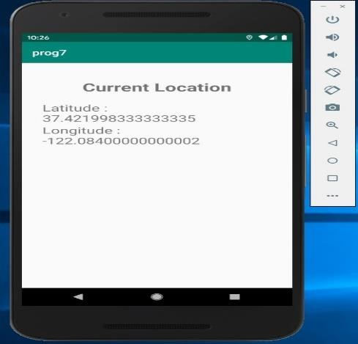

**Program-7: Create an application that read/writes data to the internal storage of mobile.**

**Activity_main. Xml:**

*<?*xml version="1.0" encoding="utf-8"*?>*

### <RelativeLayout

xmlns:android="http://schemas.android.com/apk/res/android" xmlns:tools="http://schemas.android.com/tools" android:layout_width="match_parent"

android:layout_height="match_parent"

>

<TextView android:id="@+id/textView1" android:layout_width="wrap_content" android:layout_height="wrap_content" android:layout_alignParentLeft="true" android:layout_alignParentRight="true" android:padding="5dp"

android:text="Android Read and Write Text from/to a File" android:textStyle="bold"

android:textSize="28sp" />

### <EditText

android:id="@+id/editText1" android:layout_width="wrap_content" android:layout_height="wrap_content" android:hint="Enter Text" android:layout_alignParentLeft="true" android:layout_alignParentRight="true" android:layout_below="@+id/textView1" android:layout_marginTop="22dp" android:minLines="5" android:layout_margin="5dp">

<requestFocus /> </EditText>

### <Button

android:id="@+id/button1" android:layout_width="wrap_content" android:layout_height="wrap_content" android:text="Write Text into File" android:onClick="WriteBtn" android:layout_alignTop="@+id/button2" android:layout_alignRight="@+id/editText1" android:layout_alignEnd="@+id/editText1" /> <Button android:id="@+id/button2" android:layout_width="wrap_content" android:layout_height="wrap_content" android:text="Read Text From file" android:onClick="ReadBtn" android:layout_centerVertical="true" android:layout_alignLeft="@+id/editText1"

android:layout_alignStart="@+id/editText1" />

<Button android:id="@+id/button3" android:layout_width="wrap_content" android:layout_height="wrap_content" android:layout_below="@id/button1" android:layout_marginTop="30dp" android:onClick="ClearBtn"

android:text="Clear" />

### </RelativeLayout>

**Java:** package com.example.myinternalfile;

import android.os.Bundle; import android.app.Activity; import android.view.View; import android.widget.EditText; import android.widget.Toast; import java.io.FileInputStream; import java.io.FileOutputStream; import java.io.InputStreamReader;

import java.io.OutputStreamWriter;

public class MainActivity extends Activity {

EditText textmsg;

static final int *READ_BLOCK_SIZE* = 100;

## @Override

protected void onCreate(Bundle savedInstanceState) { super.onCreate(savedInstanceState);

setContentView(R.layout.*activity_main*);

textmsg=(EditText)findViewById(R.id.*editText1*);

}

*// write text to file* public void WriteBtn(View v) { *// add-write text into file* try {

FileOutputStream fileout=openFileOutput("mytextfile.txt", *MODE_APPEND*); OutputStreamWriter outputWriter=new OutputStreamWriter(fileout);

outputWriter.write(textmsg.getText().toString()); outputWriter.close();

*//display file saved message*

Toast.*makeText*(getBaseContext(), "File saved successfully!",

Toast.*LENGTH_SHORT*).show();

} catch (Exception e) { e.printStackTrace();

}

}

*// Read text from file* public void ReadBtn(View v) { *//reading text from file*

### try {

FileInputStream fileIn=openFileInput("mytextfile.txt");

InputStreamReader InputRead= new InputStreamReader(fileIn);

char[] inputBuffer= new char[*READ_BLOCK_SIZE*];

String s="";

int charRead;

while ((charRead=InputRead.read(inputBuffer))>0) {

*// char to string conversion*

String readstring=String.*copyValueOf*(inputBuffer,0,charRead); s +=readstring;

}

InputRead.close();

textmsg.setText(s);

} catch (Exception e) { e.printStackTrace();

}

}

public void ClearBtn(View v) { textmsg.setText("");

}

}

**OUTPUT:**

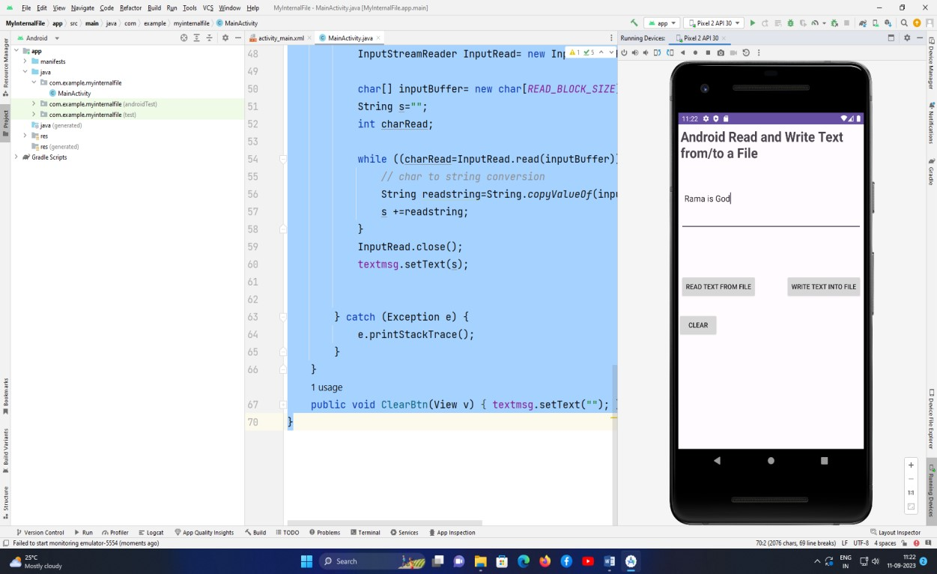

**Program-8: Build a mobile application to send SMS based on given mobile number with PendingIndents**

**Activity_main.xml**

*<?*xml version="1.0" encoding="utf-8"*?>*

<LinearLayout xmlns:android="http://schemas.android.com/apk/res/android" xmlns:app="http://schemas.android.com/apk/res-auto" xmlns:tools="http://schemas.android.com/tools" android:layout_width="match_parent" android:layout_height="match_parent" android:orientation="vertical"

tools:context=".MainActivity" >

### <TextView

android:id="@+id/textView" android:layout_width="match_parent" android:layout_height="wrap_content" android:layout_marginTop="50dp" android:gravity="center" android:text="SMS Delivery APP" android:textColor="#B15031" android:textSize="35sp"

android:textStyle="bold" />

### <EditText

android:id="@+id/editText1" android:layout_width="match_parent" android:layout_height="wrap_content" android:layout_marginTop="50dp" android:ems="10"

android:hint="Enter Mobile Number" android:inputType="phone" android:textColor="#33B339" android:textSize="25sp"

android:textStyle="bold" />

### <EditText

android:id="@+id/editText2" android:layout_width="match_parent" android:layout_height="150dp" android:layout_marginTop="25dp" android:ems="10" android:hint="Enter Message" android:inputType="text|textMultiLine" android:textColor="#2A6DA3" android:textSize="25sp" android:textStyle="bold" />

### <Button

android:id="@+id/Btn" android:layout_width="match_parent" android:layout_height="wrap_content" android:layout_marginTop="60dp" android:text="SEND" android:textSize="25sp"

android:textStyle="bold" />

### </LinearLayout>

**Java:**

package com.example.mysmsdeliveryapp;

import android.Manifest; import android.app.Activity; import android.app.PendingIntent; import android.content.BroadcastReceiver; import android.content.Context; import android.content.Intent;

import android.content.pm.PackageManager; import android.os.Bundle; import android.telephony.SmsManager; import android.view.View; import android.widget.Button; import android.widget.EditText;

import android.widget.Toast;

public class MainActivity extends Activity {

private static final int *MY_PERMISSIONS_REQUEST_SEND_SMS* = 123; *// You can choose any unique request code*

private EditText recipientEditText; private EditText messageEditText; private Button sendButton;

private PendingIntent sentPendingIntent; private PendingIntent deliveredPendingIntent;

## @Override

protected void onCreate(Bundle savedInstanceState) { super.onCreate(savedInstanceState); setContentView(R.layout.*activity_main*);

recipientEditText = findViewById(R.id.*editText1*); messageEditText = findViewById(R.id.*editText2*); sendButton = findViewById(R.id.*Btn*); sentPendingIntent = PendingIntent.*getBroadcast*(this, 0,

new Intent("SMS_SENT"), PendingIntent.*FLAG_IMMUTABLE*);

deliveredPendingIntent = PendingIntent.*getBroadcast*(this, 1,

new Intent("SMS_DELIVERED"), PendingIntent.*FLAG_IMMUTABLE*);

sendButton.setOnClickListener(view -> {

String recipient = recipientEditText.getText().toString(); String message = messageEditText.getText().toString();

if (recipient.isEmpty() || message.isEmpty()) {

Toast.*makeText*(MainActivity.this, "Recipient and message cannot be empty",

Toast.*LENGTH_SHORT*).show(); return;

}

*// Check for permission before sending SMS*

if (checkSelfPermission(Manifest.permission.*SEND_SMS*) !=

PackageManager.*PERMISSION_GRANTED*) {

*// Permission is not granted, request it*

requestPermissions(new String[]{Manifest.permission.*SEND_SMS*},

*MY_PERMISSIONS_REQUEST_SEND_SMS*);

### } else {

*// Permission is already granted, send the SMS* sendSMS(recipient, message);

}

});

}

private void sendSMS(String recipient, String message) { try {

SmsManager smsManager = SmsManager.*getDefault*();

smsManager.sendTextMessage(recipient, null, message, sentPendingIntent, deliveredPendingIntent);

Toast.*makeText*(this,"Message Sent Successfully", Toast.*LENGTH_SHORT*).show(); } catch (Exception e) {

Toast.*makeText*(this, "Failed to send SMS", Toast.*LENGTH_SHORT*).show(); e.printStackTrace();

}

}

## @Override

public void onRequestPermissionsResult(int requestCode, String[] permissions, int[] grantResults) { super.onRequestPermissionsResult(requestCode, permissions, grantResults);

if (requestCode == *MY_PERMISSIONS_REQUEST_SEND_SMS*) {

if (grantResults.length > 0 && grantResults[0] == PackageManager.*PERMISSION_GRANTED*) { *// Permission granted, send the SMS*

String recipient = recipientEditText.getText().toString(); String message = messageEditText.getText().toString(); sendSMS(recipient, message);

### } else {

*// Permission denied, show a message to the user*

Toast.*makeText*(this, "SMS permission denied. Cannot send SMS.",

Toast.*LENGTH_SHORT*).show();

}

}

}

}

Manifest.xml

*<?*xml version="1.0" encoding="utf-8"*?>*

<manifest xmlns:android="http://schemas.android.com/apk/res/android" xmlns:tools="http://schemas.android.com/tools">

### <uses-feature

android:name="android.hardware.telephony"

android:required="false" />

<uses-permission android:name="android.permission.SEND_SMS"/>

### <application

android:allowBackup="true" android:dataExtractionRules="@xml/data_extraction_rules" android:fullBackupContent="@xml/backup_rules" android:icon="@mipmap/ic_launcher" android:label="@string/app_name" android:roundIcon="@mipmap/ic_launcher_round" android:supportsRtl="true"

android:theme="@style/Theme.MySMSDeliveryApp"

tools:targetApi="31">

### <activity

android:name=".MainActivity" android:exported="true">

### <intent-filter>

<action android:name="android.intent.action.MAIN" />

<category android:name="android.intent.category.LAUNCHER" />

</intent-filter> </activity> </application>

### </manifest>

Output:

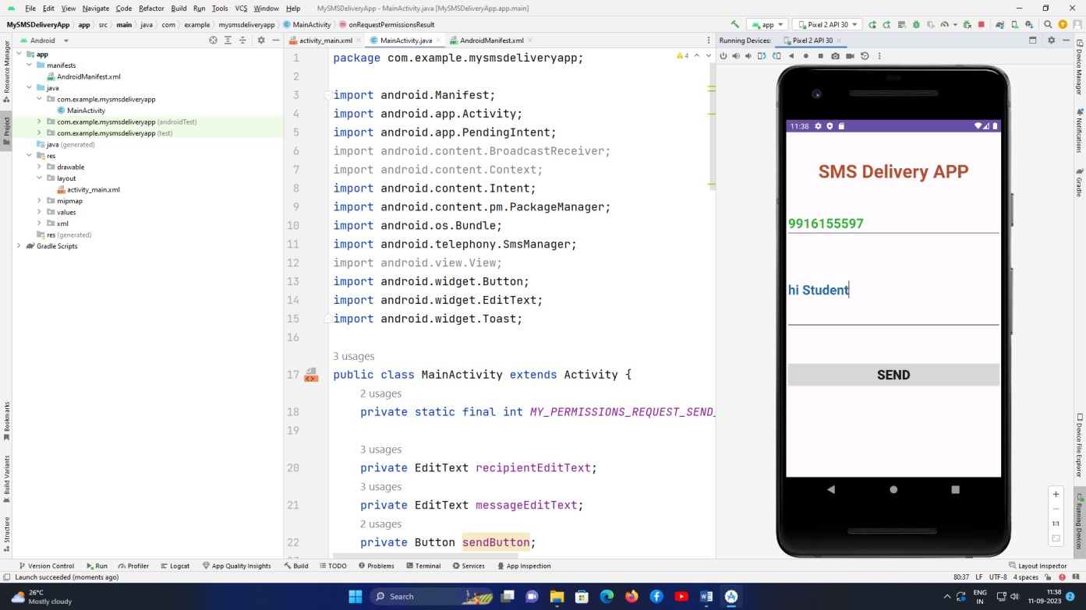

**Program-9: Create simple mobile application using Flutter (Open Ended Program)**

Instructions: Student can create any simple mobile application on any scenario using Flutter IDE